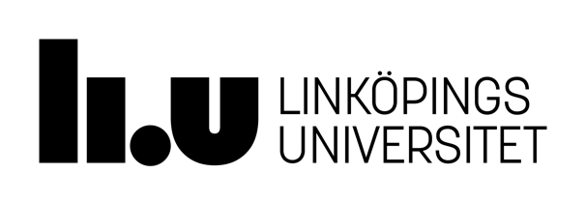

Department of Culture & Society
Institutionen för kultur och samhälle (IKOS)

READING LIST
Spring Semester 2023

Language Studies, Intermediate Course, 7.5 credits
Spring 20223
Course code: 711G47

Course Literature & Compendiums
Books have been ordered through Bokakademin in Kårallen (the Student Union).
Course compendiums and materials will be available in electronic form via LISAM.

Language Studies

Course Literature

Yule, George. The Study of Language, 5th ed. Cambridge: Cambridge University Press, 2014.

Materials supplied by the Department (via Lisam).

Reference Literature

Brown, Penelope & Levinson, Stephen C. Politeness: Some Universals in Language Usage. Cambridge: Cambridge University Press, 1987.

Chandler, Daniel. Semiotics for Beginners (1994–2015) [online]. Available from
<http://visual-memory.co.uk/daniel/Documents/S4B/?LMCL=WzhsMg> [29 December
2019]

Crystal, David. The Cambridge Encyclopedia of the English Language, 2nd edn. Cambridge:
Cambridge University Press, 2005.

Ellis, Rod, & Barkhuizen, Gary. Analysing Learner Language. Oxford: Oxford University Press, 2005.

Gee, James & Handford, Michael, eds. The Routledge Handbook of Discourse
Analysis. London: Routledge, 2013 [online]. Available from <http://lib.myilibrary.com.e.bibl.liu.se/ProductDetail.aspx?id=500529> [29 December 2019]

Hutchby, Ian. & Wooffitt, Robin. Conversation Analysis, 2nd ed. Cambridge: Polity
Press, 2008.

O’Keeffe, Anne & McCarthy, Michael, eds. The Routledge Handbook of Corpus Linguistics. London: Routledge, 2012 [online]. Available from <http://lib.myilibrary.com.e.bibl.liu.se/ProductDetail.aspx?id=258997> [29 December 2019]

Romaine, Suzanne. Language in Society, 2nd ed. Oxford: Oxford University Press, 2000.
Saeed, John. Semantics, 2nd ed. Oxford: Blackwell, 2003.

Varieties of English

Course Literature

Armstrong, Eric. Journey of the Voice [online]. Available from <http://www.yorku.ca/earmstro/journey/index.html> [29 December 2019]

British Library. Learning. Sounds Familiar [online]. Available from <http://www.bl.uk/learning/langlit/sounds/index.html> [29 December 2019]

Crystal, David. The Cambridge Encyclopedia of the English Language, 3rd ed. Cambridge: Cambridge University Press, 2018. [ISBN: 9781108437738]

Reference Literature

Schneider, Edgar W. English Around the World: An Introduction. Cambridge: Cambridge University Press, 2011. [online] available from [the LiU Library as an ebook] <https://ebookcentral.proquest.com/lib/linkoping-ebooks/detail.action?docID=605108> [29 December 2019]

Svartvik, Jan & Leech, Geoffrey. English. One Tongue, Many Voices. Basingstoke: Palgrave Macmillan, 2006.

Yule, George. The Study of Language, 6th ed. [or later]. Cambridge: Cambridge University Press, 2016. [ISBN: 9781316606759]

N.B. In conjunction with the essay exam, you will also receive a list of recommended reading tailored to the essay topic.

